Devan Checkout Usability Guide

# PAGE 1

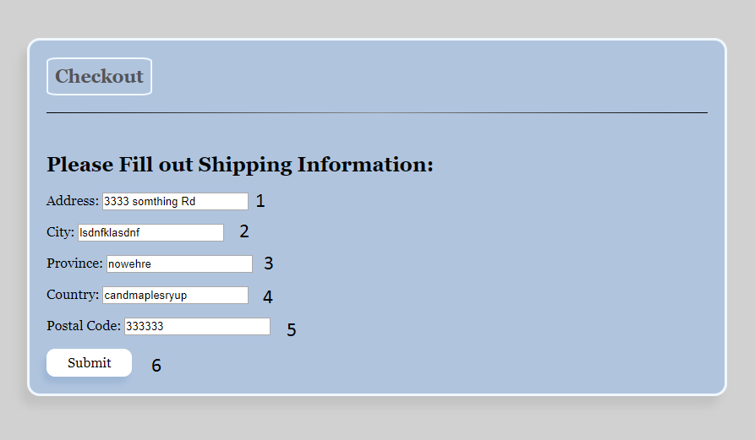

1. Textbox to enter your Address, which is required and it will be checked to see if its valid
2. Textbox to enter your City, which is required
3. Textbox to enter your Province, which is required
4. Textbox to enter your Country, which is required
5. Textbox to enter your Postal Code, which is required
6. Submit button to enter your information and move to page 2 of checkout. When this button is pressed, if you never entered a address before, it will be saved to the database and next time you visit this page the textboxes will be filled automatically. If you have entered a address before and if any of the textboxes have different text than what is saved, the database will be updated.

# PAGE 2

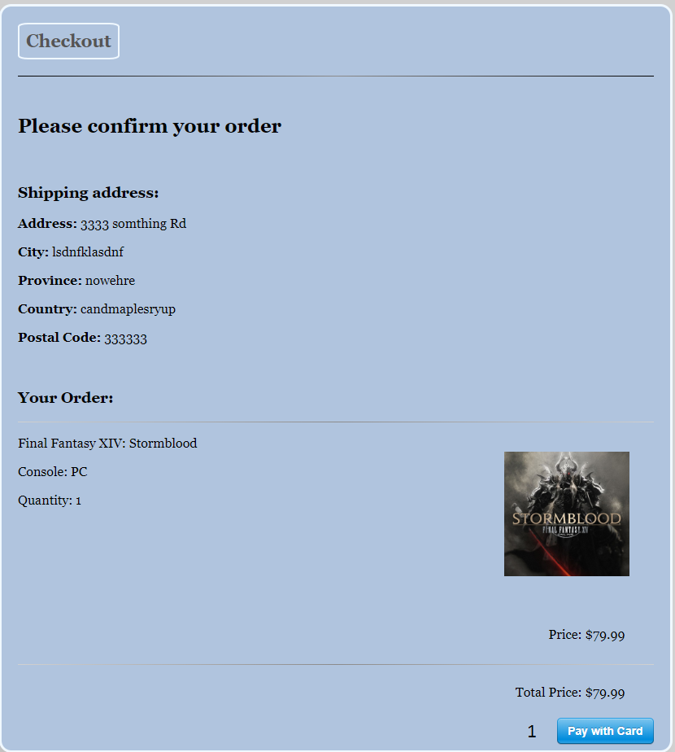

1. When clicked, Stripe will open to start the payment process

# Stripe Payment

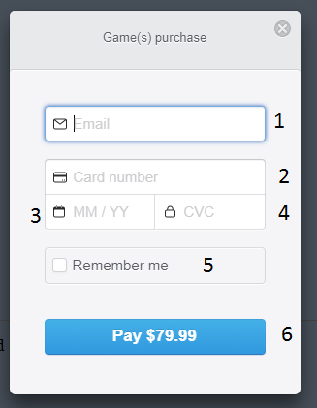

1. Enter email for stripe receipt, this is required and will be validated
2. Enter your credit card number, this is required and will be validated
3. Enter the expiry for your credit card, this is required
4. Enter CVC, this is required
5. Check this to have stripe remember this information, you will have to sign up to do this though
6. Confirm and pay the amount listed.

# PAGE 3

